EEE521 Computer and Data Communication Networks
Semester 2 2011/2012
Preparatory questions for Random Access Control and LANs

These questions facilitate the discussion random access methods in computer networks.
Preparatory readings: Students should read Forouzan’s Text book – Chapter 12.1, 13.1 and preparatory notes for Interconnecting LANs. Students should also complement the materials with other supplementary reading resources. Students are advised to attempt as many questions as they can before the lecture and complete the answers before, during and after the discussion. It is not compulsory to hand in the answers. Properly done, these questions and answers can be used as your study notes.
- What are the four random contention access methods in computer networks?
  - ____________________________________
  - ____________________________________
  - ____________________________________
  - ____________________________________
- Random contention access can be represented by the Poisson process. What is the definition of Poisson process?
_________________________________________________________________________________________________________________________________________________________________________________________________________________________________
- State the Poisson formula for the probability of k number of occurrences in the time interval in terms of k, τ and λ where λ is the expected number of occurrences per unit time.
_________________________________________________________________________________________________________________________________________________________________________________________________________________________________
- Pure ALOHA throughput derivation.
If λ refers to the expected number of access attempts per second, and τ refers to the time to transmit a frame into the communication medium (ie. The frame transmission time or in short the frame time), what is the normalised load, G per frame time?
_________________________________________________________________________________________________________________________________________________________________________________________________________________________________
- Based on the Poisson formula, what is the probability of there being k attempts to access the channel?
______________________________________________________________________________________________________________________________________________________________________________________________________________________________________________________
- What does it mean by the vulnerable period in random contention access? How long is the duration of the vulnerable period for Pure ALOHA scheme? _____________________________________________________________________________________________________________________________________________________________________________________________________________________________________________
- What is the probability of there being k access attempts during the vulnerable period in Pure ALOHA?
_________________________________________________________________________________________________________________________________________________________________________________________________________________________________
- If the probability of success is defined as the probability of no access attempts during the vulnerable period, work out the expression for the probability of success, P_{success} in terms of the normalised load, G for Pure ALOHA scheme.
_________________________________________________________________________________________________________________________________________________________________________________________________________________________________
- What does it mean by the throughput in computer and data communication network?
_________________________________________________________________________________________________________________________________________________________________________________________________________________________________
- If the throughput , S can be represented by the product of the rate of access attempts, G and the probability of successful access, P_{success}, what is the expression for the throughput, S in terms of the normalised load,G for Pure ALOHA scheme?
_________________________________________________________________________________________________________________________________________________________________________________________________________________________________
- Based on your answer to question number 10, what is the maximum throughput, S_{max} for Pure ALOHA? At what value of the normalised load, G does the maximum throughput occur?
_________________________________________________________________________________________________________________________________________________________________________________________________________________________________
- A pure ALOHA network transmits 200-bit frames on a shared link of 200kbps. If the host generates 1000 frames per second, work out the throughput of the network? How many of the 1000 frames get through to the destination without collision?
_________________________________________________________________________________________________________________________________________________________________________________________________________________________________
- How do the source stations in computer networks know that they have to retransmit the sent data that have collided with data sent by other source stations?
_________________________________________________________________________________________________________________________________________________________________________________________________________________________________
- How does the Pure ALOHA scheme prevent repeated data collision?
_________________________________________________________________________________________________________________________________________________________________________________________________________________________________
- How does the Pure ALOHA scheme prevent network congestion due to the retransmitted frames?
_________________________________________________________________________________________________________________________________________________________________________________________________________________________________
- How long is the duration of the slot in Slotted ALOHA?
_________________________________________________________________________________________________________________________________________________________________________________________________________________________________
- When can stations attempt to access the channel in Slotted ALOHA scheme?
_________________________________________________________________________________________________________________________________________________________________________________________________________________________________
- How long is the duration of the vulnerable time in Slotted ALOHA?
_________________________________________________________________________________________________________________________________________________________________________________________________________________________________
- Derive the throughput for the Slotted ALOHA, S _{Slotted_ALOHA}.
_____________________________________________________________________________________________________________________________________________________________________________________________________________________________________________________________________________________________________________________________________________________________________________________________________________________________________________________________________________________________________________________________________________
- Workout the maximum throughput for Slotted ALOHA, S _{Max_Slotted_ALOHA}.
__________________________________________________________________________________________________________________________________________________________________________________________________________________________________________________________________________________________________________________________________________________________________________________________________________________________________________________________________
- A Slotted ALOHA network transmits 200-bit frames on a shared link of 200kbps. If the host generates 1000 frames per second, work out the throughput of the network? How many of the 1000 frames get through to the destination without collision?
_________________________________________________________________________________________________________________________________________________________________________________________________________________________________
- Compare the throughput of Pure ALOHA and Slotted ALOHA.
_________________________________________________________________________________________________________________________________________________________________________________________________________________________________
- Sketch graphs for throughput, S against the normalised load, G for G=0 to G=3, for both Pure ALOHA and Slotted ALOHA (you should sketch two lines on one graph and include the corresponding maxima).

- What is the action taken by all stations in CSMA scheme in order to reduce the chance of data collision?
_____________________________________________________________________________________________________________________________________________________________________________________________________________________________________________
- Can this action eliminate the possibility of data collision? Why?
_____________________________________________________________________________________________________________________________________________________________________________________________________________________________________________
- How long is the duration of the vulnerable period in CSMA scheme?
_____________________________________________________________________________________________________________________________________________________________________________________________________________________________________________
- What are the three variations of the CSMA scheme?
_____________________________________________________________________________________________________________________________________________________________________________________________________________________________________________
- What are the differences between I-persistent and non-persistent CSMA schemes?
_____________________________________________________________________________________________________________________________________________________________________________________________________________________________________________
- Between I-persistent and non-persistent CSMA, which one has the lower chance of data collision? Why?
_____________________________________________________________________________________________________________________________________________________________________________________________________________________________________________
- What do you think the efficiency of the CSMA schemes depend on?
_____________________________________________________________________________________________________________________________________________________________________________________________________________________________________________
- A parameter a is defined as the normalised propagation delay, a = T_{p} / T_{fr}. Graphs below show the throughput , S against the normalised load, G for different values of the parameter, a for 1-persistent and non-persistent CSMA.
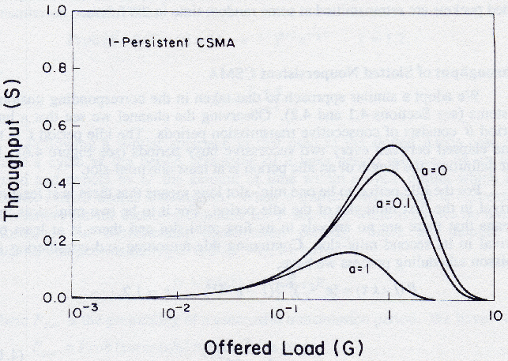

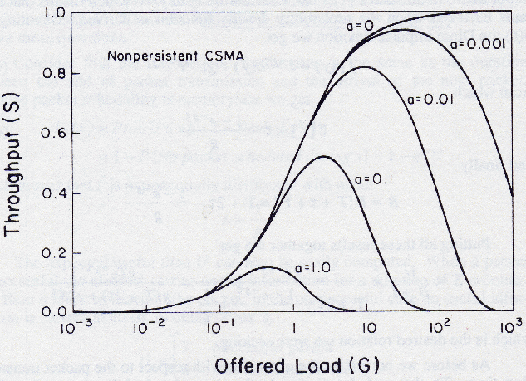
Based on the graphs, compare and contrast the throughput between I-persistent and non-persistent CSMA schemes.
_________________________________________________________________________________________________________________________________________________________________________________________________________________________________________________________________________________________________________________________________________________________________________________________________________________________________________________________________________________________________________

- Why CSMA causes lower link utilisation when data collision occurs? _____________________________________________________________________________________________________________________________________________________________________________________________________________________________________________
- What actions are taken by stations in CSMA/CD in order to help increase channel utilisation?
_____________________________________________________________________________________________________________________________________________________________________________________________________________________________________________
- The graph below shows the throughput, S against the normalised load, G for all the random contention access schemes.
Comment on the performance of CSMA/CD scheme compared to the other schemes and give the reason for the performance.
____________________________________________________________________________________________________________________________________________________________________________________________________________________________________________________________________________________________________________________________
- Which scheme will you select when setting up a local area network in the students’ apartments, i) during the semester break , and ii) in the middle of the semester?
_____________________________________________________________________________________________________________________________________________________________________________________________________________________________________________
- The Data Link Layer in the IEEE Standard is divided into two sublayers. Give the names and the functions of both sublayers?
_____________________________________________________________________________________________________________________________________________________________________________________________________________________________________________
- What are the minimum and maximum frame sizes for the Standard Ethernet?
_____________________________________________________________________________________________________________________________________________________________________________________________________________________________________________
- What is the multiple access method used in the Standard Ethernet?
_____________________________________________________________________________________________________________________________________________________________________________________________________________________________________________
- What is the major difference between LAN connecting devices that work at only the physical layer and the ones that work at both the physical and data link layer?
_________________________________________________________________________________________________________________________________________________________________________________________________________________________________

